Lab : Diodes & DC Power Supplies
Name(s):_______________________________________

Purpose: To gain hands-on experience in constructing AC-to-DC power conversion circuitry using semiconductor components.

Overview: In this lab, we will start with a simple half-wave rectifier and build up to a DC power supply using a bridge rectifier and capacitive filter. We will also do some thinking about the use of voltage regulators!

Equipment:
- CircuitLab.com simulation website.

Instructions:

Log in to Circuitlab.com, and build the following circuits as instructed, simulating their output and pasting the simulation results in the allocated space.

Next page…

Part I: Half-Wave Rectifier
1. Build the circuit below, using the default diode available (in the menu on the left), and a 100Ω resistor. Use an AC source voltage with 5V amplitude, at 60 Hz.
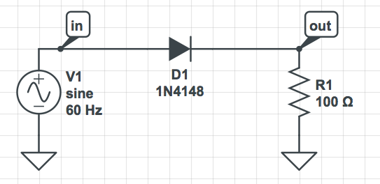

2. Then Simulate the circuit:
- Click on “Simulate” on the bottom right, then “Time Domain”.
- Do “Add Expression” and click on the “in” and “out” tags to add “V(in)” and “V(out)” to the Outputs for the simulator.
- Set the Stop Time to 0.1s and the Time Step to “0.1m” s. Leave the other fields as their defaults.
- Click “Run Time-Domain Simulation”.
- Get a copy of the graph, either by selecting “Export Plot Images” or by doing a screen capture (on a Mac: Command-Shift-4), and Past the picture into the following space:

Question:
1. Using the mouse over various parts of the graph do you measure the voltage drop across your diode to be? (Hint: it’s the difference between V(in) and V(out))

Part II: Full-Wave Rectifier
1. Now modify your previous circuit to construct the Full-Wave “bridge” rectifier shown below. (This was made by deleting the previous diode, and moving the resistor to the right to make some space. Use the “left” of the two available transformers, and right click on each diode as you add it to select “flip vertically” if needed.)
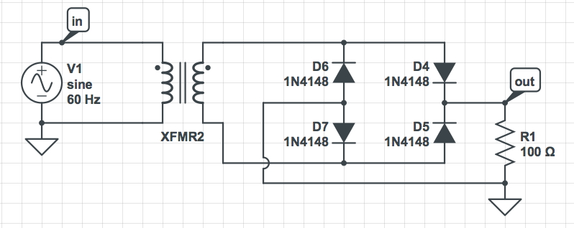

2. Simulate it and paste the graph in the space below. You should not need to modify any previous Time Domain settings.

Part III: Filtered Power Supply
1. Now insert a “large” (100mF) capacitor to function as a "filter" in the circuit you just built, as shown below.
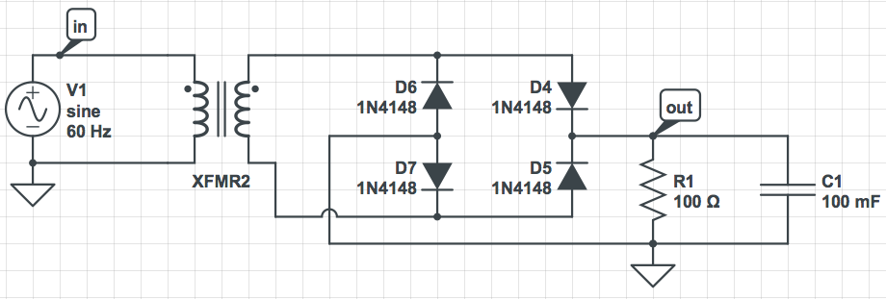

For this Time Domain Simulation, change the Stop Time to “0.5” s and the Time Step to “0.5m” s. Paste the output graph below:

2. Modify the size of the filtering capacitor to “100u” F (i.e. 100 microFarad). This will be the “small” capacitor. Paste the output below:

Questions:
1. For the small capacitor…
a. What is the maximum voltage obtained by the filtered full-wave signal?
b. What is the amplitude of the “ripple” voltage?

2. What are the qualitative effects of increasing the capacitance in the filter?

The End.

