PHY2010.02
December 7, 2009

The O-Port: An Analysis
Laura Gearhart, David Jeffries, Michael Rohr, Nate Taylor

Abstract:

This project’s intent was to test the validity of the O-Port’s claims of improved frequency response, enhanced resonance, and feedback reduction in acoustic guitars. In doing this, two guitars were tested and compared with and without the O-Port in frequency response, resonance and sound quality. While sound quality is somewhat subjective, frequency and resonance were quantified by averaging multiple recorded strums of the same chord/harmonic series. Feedback was tested using a guitar with a pick-up on a stand, and driving the guitar until it fed back. The O-Port’s claims were lofty, and this project tested to see if any of these claims hold up

Introduction:

Musicians and audio engineers are constantly looking for ways to improve the sound of their instruments and recordings. These improvements can easily cost hundreds, if not thousands of dollars, and be difficult to install and confusing to use. The makers of the O-Port, however, believe that they have created a device that will make a significant improvement in the sound of a guitar that is still cheap and easy to use. Their product, a simple, bell-shaped, plastic ring, works by adjusting the Helmholtz resonance of the body of the guitar. In their literature, they claim that it “will make any guitar- from beginner to custom- sound richer, fuller, louder, with more clarity and better projection,” that it “eliminates feedback,” and include frequency spectrum graphs of the 5th fret harmonic of a guitar with and without the O-Port to prove this. According to the instructions, all that is necessary to achieve these improvements is to place the O-Port in the sound hole of a guitar, and start to play. The goal of this project was to test the validity of these claims through frequency spectrum analysis and comparison of audio samples recorded with and without the O-Port.
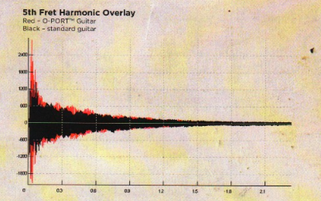
Figure 1: Manufacturer’s Sustain Claims

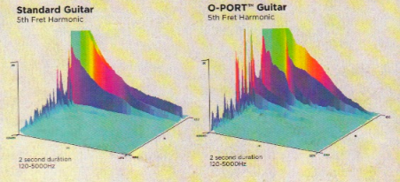
Figure 2: Manufacturer’s Claims Figure 3: Manufacturer’s Claims

Procedure:

In testing the O Port, two guitars were analyzed; a large bodied Gibson Gospel and a small bodied Rogue Grand Concert. Guitars were tested with and without the O Port in terms of frequency, sustain, feedback resistance, and sound quality. Tests were conducted by recording several audio samples using an Audix TR-40 and analyzing results via Audacity. Sound quality samples were recorded with a Shure KSM27.

Through the experiment, a proper control was a large concern. To obtain this when testing, guitar strings (Constant: D’Addario Medium-Gauge Bronze) were changed every time the O Port was inserted or removed. When changing strings, there was a constant length of string winding (2.625”), as well as a constant string stretching procedure ((ten) three pull stretches/retunes per string) to preserve tuning stability throughout the experiment.

Audio samples were recorded with an Audix Reference microphone from a distance of 1ft from the center of the sound hole. Samples recorded included approximately: thirty strums of an E-Chord, thirty sweeps of fifth fret harmonics, ten decaying E-Chords, and ten decaying sweeps of fifth fret harmonics. These multiple samples were performed with the intent of averaging to minimize human error in strumming. All tests were done with a fixed gain structure, recording through a Digidesign MBox2 mic preamp/audio interface into Audacity. Audacity was used for all FFT spectrum analysis. Harmonic tests were exported en mass, then averaged and plotted in Excel. Sustains were compared visually using Audacity’s waveform view set to dB. Resonance tests were analyzed using Audacity’s built-in FFT feature.

Feedback reduction was tested by placing the Rogue Grand Concert (Fishman Pickup Equipped) on a guitar stand 3 ft. from a Mackie HD-1521 loudspeaker. The speaker was placed off-axis from the guitar to replicate the positioning of a standard monitor wedge. Signal from the Rogue’s internal pickup (set at Max Output/flat E.Q.) was routed to a channel on a Carvin 1644p mixer. The mixer’s main output was then routed to the Mackie HD-1521. The test was conducted by setting unity gain on the channel and increasing the master output (starting from – ∞) until the point of feedback.

Results:

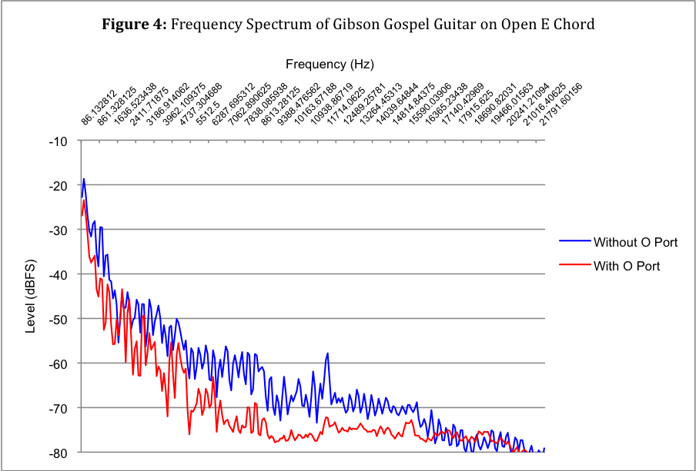
Measurements of the frequency spectrum of the guitars with and without the O-Port were averaged, plotted, and analyzed. The frequency spectrum of the Gibson Gospel guitar showed a significant loss of frequency content in the low and middle bands (Figure 4). There was about a 4 dB drop of the fundamental frequency at the bottom of the chord (86 Hz) and the level with the O-PORT is generally lower, apart from a few peaks in the low mid frequencies and at the uppermost highs. This corresponds to what was heard during testing, with the guitar losing overall volume, and especially losing low end.

The frequency content of the Gibson Guitar strummed at the 5th fret harmonic, however, yielded different results. The manufacturer claimed an increase in middle harmonics in its literature. This test’s results (Figure 5) showed that with the O-Port, the frequency content of the guitar was similar to without, except for a couple of spikes (~1 kHz and ~3kHz) that may correspond to what was being claimed by the manufacturer. There was also an overall boost with the O-Port in the 8-10 kHz region. Overall, the frequency content of the fifth harmonic was not nearly as affected as the open E Chord.

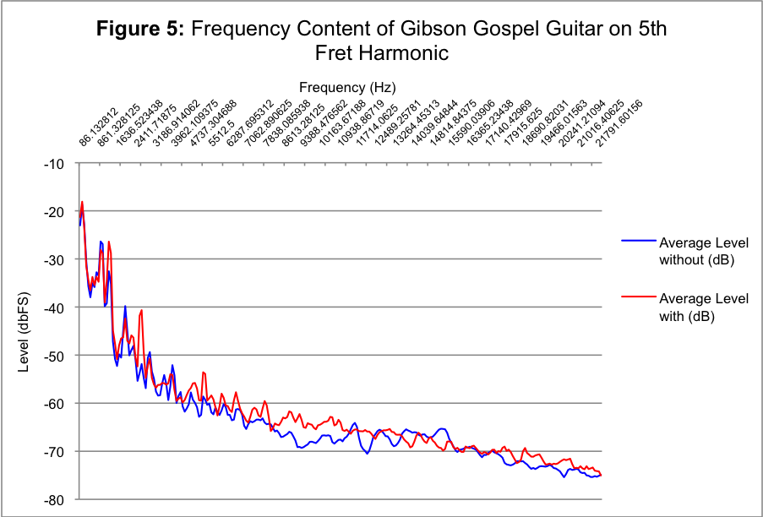
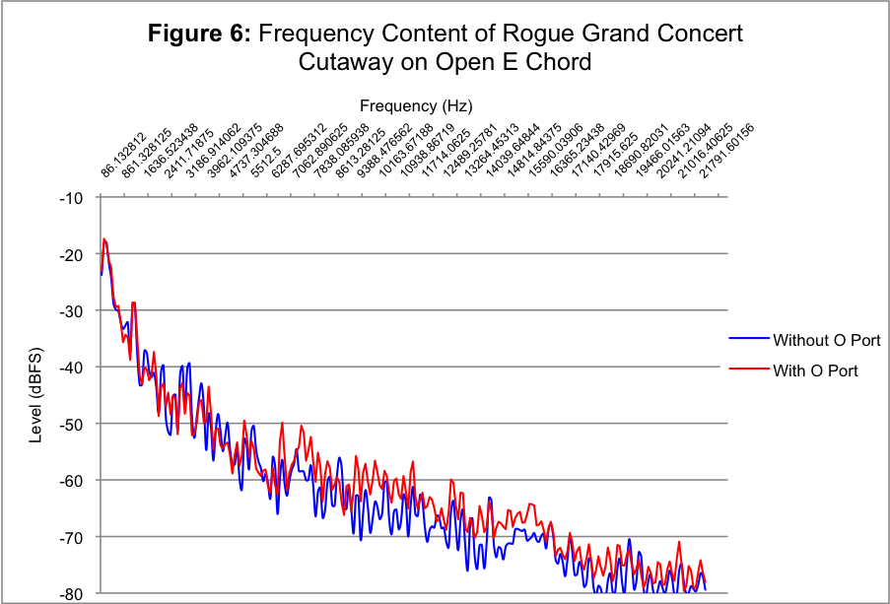
The frequency content of the Rogue Grand Concert Cutaway (Figure 6) showed less drastic results when adding the O-Port. The frequency content of the open E Chord was very close between with and without, and the loss of lows and mids that was seen in the Gibson was not replicated here. In fact, the O-Port appeared to boost some of the upper middle frequencies, something not seen in the Gibson guitar. With the Rogue on the 5th fret harmonics, the results were similar to the Gibson on the same test. There were a couple spikes in the low mids, as predicted by the manufacturer, and a slight gain in some of the high mids. Overall, the frequency responses were closer together than with the Gibson.

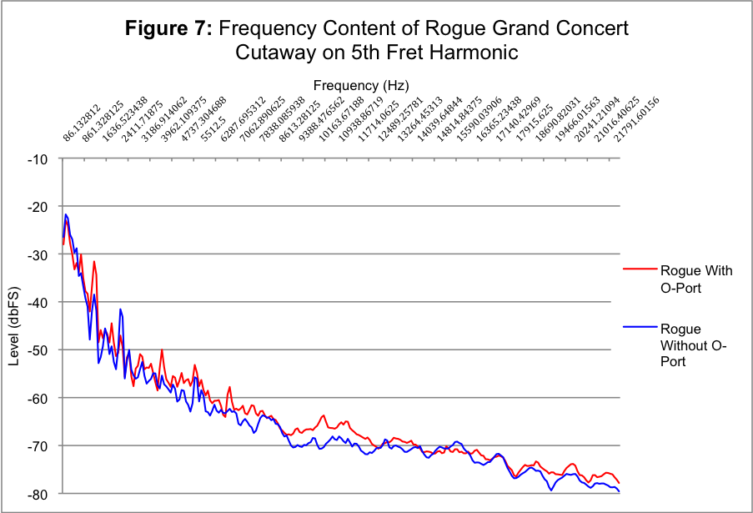

The guitars were also tested by driving them with pink noise and measuring the frequency response with and without the O-Port. It was found that the O-Port lowers the resonant frequency of the guitar and also lowers the amplitude of the resonance.

The Gibson guitar had a resonance at 99 Hz with an amplitude of -11.1 dBFS without the O Port (Figure 8). With the O Port its resonance was at 85 Hz with an amplitude of -13.0 dBFS (Figure 9).

The Rogue guitar had a resonance at 99 Hz with an amplitude of -11.1 dBFS without the O Port (Figure 10). With the O Port its resonance was at 85 Hz with an amplitude of -13.0 dBFS (Figure 11).
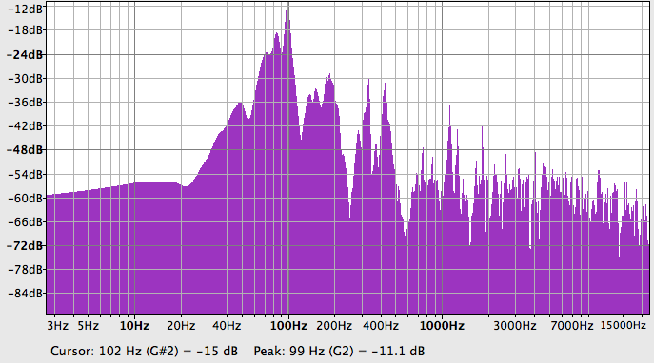
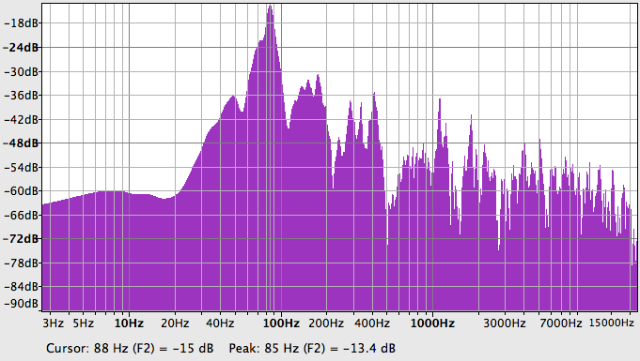
Figure 8: Resonance of Gibson Guitar Without O-Port Figure 9: Resonance of Gibson Guitar With O-Port
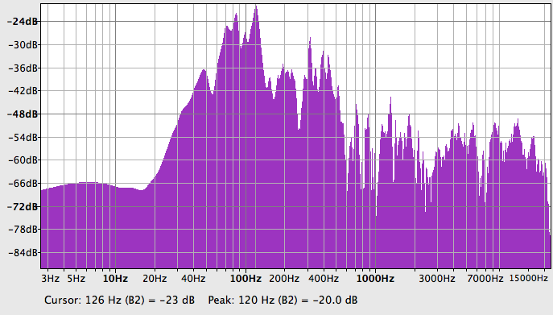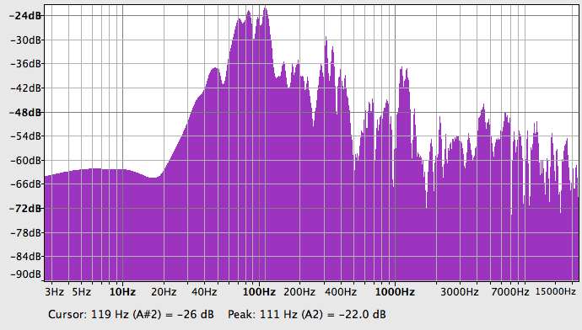
Figure 10: Resonance of Rogue Guitar Without O-Port Figure 11: Resonance of Rogue Guitar With O-Port

The guitars were also testes for their sustain with both an open E Chord and a 5th Fret Harmonic.

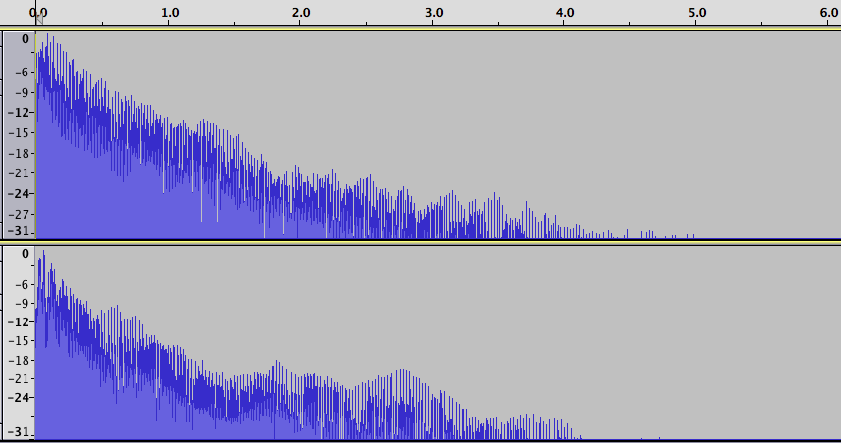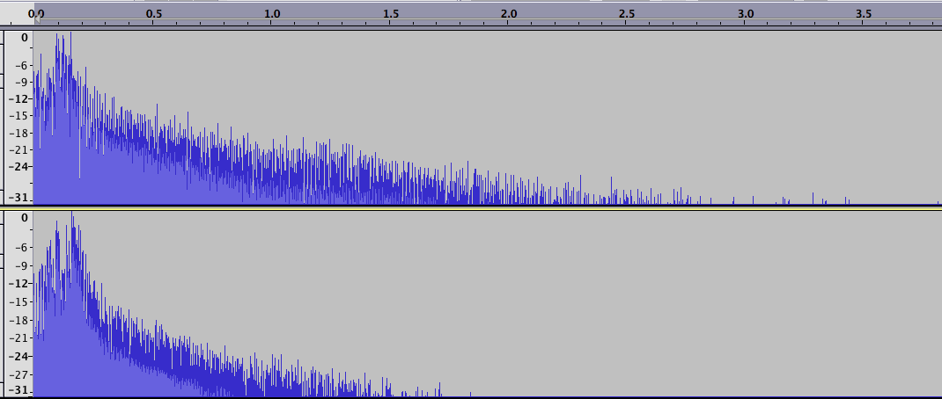
Without O-Port
Without O-Port
With O-Port
With O-Port
Figure 12: Gibson Guitar, Open E Chord Sustain Figure 13: Gibson Guitar, 5th Fret Harmonic Sustain

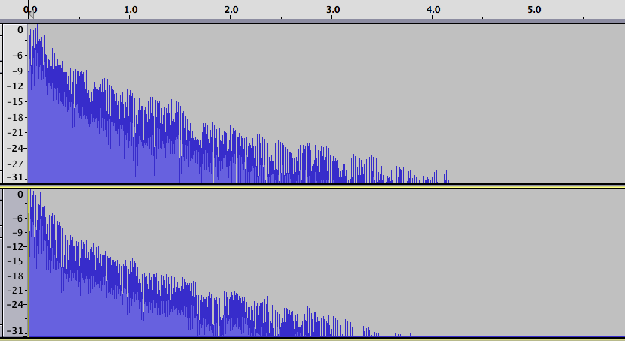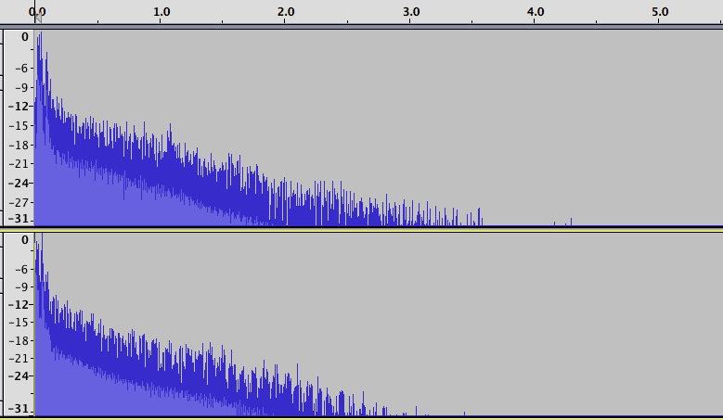
Without O-Port
With O-Port
With O-Port
Without O-Port
Figure 14: Rogue Guitar, Open E Chord Sustain Figure 15: Rogue Guitar, 5th Fret Harmonic Sustain
Here the Gibson Gospel lost almost a second of sustain by adding the O-Port on the open E chord (Figure 12). Also, adding the O-Port here created an interesting, non-linear decay characteristic. With the 5th Fret Harmonic, the guitar again lost at least a second of sustain (Figure 13). The Rogue guitar saw less drastic results, but still lost almost a half-second of sustain by adding the O-Port (Figures 14 & 15).

The Rogue guitar was tested for the O-Port’s ability to inhibit feedback. Without the O-Port, the guitar fed back at +8/9 dB on the testing setup. With the O-Port, the guitar fed back at +6 dB, loosing almost 3 dB of gain before feedback.

Conclusion:

Both objective analyses and subjective listening tests lead to the conclusion that the O-Port does not improve the sound quality of an acoustic guitar. From the data gathered it is apparent that the O-Port is altering the guitar’s sound, however it does not alter it in line with the manufacturers claims. The makers of the O-Port claim that it will improve clarity, eliminate feedback, improve sustain, and increase volume.

The added clarity caused by the O-Port seems to be achieved by lowering the resonant frequency of the guitar and dampening the low-mid frequencies. Overall, there is a loss of low end in the guitar. This causes the high-mid and high frequencies to seem louder in comparison, giving the impression of improved clarity.

The claim of feedback elimination did not make any sense in light of the other claims made about the O-Port. Feedback occurs when the source signal is amplified and then returns through the source being amplified again and again. Increasing the volume of an acoustic guitar the way the O-Port supposedly does should result in more feedback becausemore resonance creates more feedback. Our testing showed that the O-Port caused feedback 2-3 dB earlier then without.

The claims for longer sustain and increased volume were also not supported by our research. In all of our sustain tests the O-Port reduced sustain noticeably. This reduction was evident in both the fifth fret harmonic tests and the E chord tests.

Though the data we obtained and the subjective listening test we performed both seem to show that the O-Port does not perform as advertised, more data is needed for more conclusive evidence. A new test should include several guitars of various sizes and have more samples for better statistical analysis.

