Joe Hutchinson and Ben Duran
5/8/09
Project Paper
Physics for AET
Room Mode Comparisons
Abstract Overview
We investigated, measured, and analyzed the mode characteristics of two differently shaped rooms. Firstly, a symmetrical, rectangular room (which w will refer to as “Normal Room”), and secondly, a more oddly shaped room (which we will refer to as “Weird Room). We measured the modes of the rooms manually using SMAART Acoustic Tools, a keyboard amp, an interface, and a condenser microphone. We then attempted to calculate these modes using the Rayleigh Formula, and were successful for the normal room, but mostly unsuccessful for the oddly shaped room. We found that it is not possible to know or treat the modes in oddly shaped rooms, and that they are not the ideal choice for audio, because the measurement of each position in the room will show a different mode. However, with rectangular rooms, we can easily calculate the primary modes, which makes them easier to treat, and therefore, much more practical as a room used for audio.
Introduction
Being avid audio engineers requires a careful attention to detail when it comes to the entire audio palette within a particular song or mix. Countless hours are spent tweaking and fine tuning equalization settings, compression ratios, stereo pan locations, and overall presences of an audio mix. However, nothing is more frustrating than spending unfathomable amounts of time mixing a song or an album, only to find out that the “perfect mix” we had created was only perfect in the particular room in which the mix had been done. It is for this reason that we chose to delve further into modal resonance and reverberation responses of rooms.
The most common rooms available to the average audio engineer feature less-than-desirable dimensions, and are usually small cubes or rectangular boxes. An approach that is gaining more and more popularity in the recording studio design community involves the process of “splaying” the walls, or angling the walls in such a way as to eliminate unwanted flutter echoes. Since this is becoming a more common approach to studio design, we decided to try to measure and compare modal resonances of a “normal” or standard rectangular room, to those of an “odd” shaped room, or one whose walls are splayed in some form or another.
Before even choosing rooms to measure, we hypothesized that the Rayleigh formula would be our weapon of choice for analysis of the “normal” room, mostly since the formula was conceived to predict and calculate resonances of rooms with standard shapes, or ones that lack splayed walls. We also tried to hypothesize what type of behavior the “weird” room would exhibit, but there are no formulas derived to help with such oddly-shaped rooms, and any information that we obtained was either speculation or incredibly inconclusive overall.
Before conceiving the methods for gathering our data, we first need to find two rooms for comparison. Finding a “normal” shaped room required about as much thought and effort as falling asleep when tired. We did, however, want a room that was constructed with common building materials so that it would be easy to find a comparison room of similar type. For our “normal” room, we chose a small, family bathroom in the Beaman center near the basketball court. The room was of the normal “box” shape, the floors and walls were composed of concrete, the ceiling of standard acoustic tile, and it was in a part of the Beaman center where we were certain nobody would be disturbed.
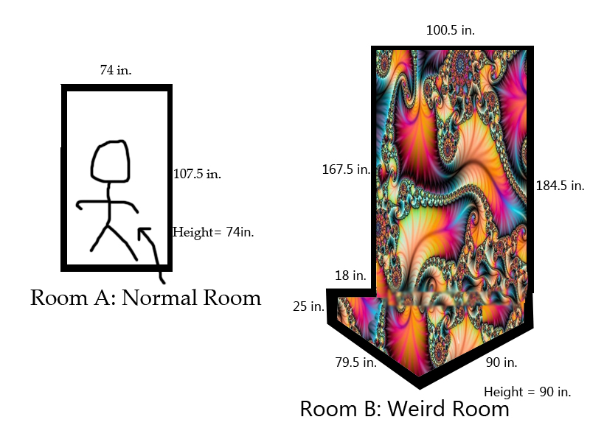
When it came to finding the “odd” shaped room, there was also a room in the Beaman center that we were both vaguely familiar with as we had walked past it one day when the door was open. It is a meeting room that is located near the athletic department, and is right next to one of the entrances to the basketball court. The room did feature a few parallel walls, but the portion that we were the most interested in was the entrance into the room. Near the door, the room had an odd “boot” shape, where the walls were splayed in a way that formed the “boot” shape. Even though we would have preferred a room that featured purely splayed walls, this room followed both predictable and non-predictable patterns, which ended up being ideal for trying to compare “normal” and “odd” shapes.
“Finding Modes, Taking Measurements”
The methods we chose to use for gathering the information regarding resonant modes and reverberation time are fairly standard. Conveniently enough, we already owned all of the equipment that we needed to properly measure the variations in these rooms (with the exception of an SPL meter, which we borrowed from our gracious Physics department). We used a Presonus Firepod recording interface as the input into Smaart, the Fourier analysis software that we used to determine the modes and reverb times in these rooms. We used both an Audio Technica AT3035 condenser microphone and a Rode NT-1A condenser microphone (we unfortunately were not able to get our hands on a working Omni-directional microphone). To drive the rooms with our Pink Noise and Sine waves, we used an Alesis Sumo 100 keyboard amp, since it has a 15” subwoofer that would be capable of blasting lower frequencies. To drive the room, we actually ended up using Pink Sync noise to begin, which is Pink Noise that repeats (is not random all the time) after a certain period, and thus, makes the response of the room remain still in the Fourier analyzer, which causes it to be much easier to read and identify.
For each room, we tried two different microphone positions during our research. We began in both cases my using the very center of the room as the first placement. In the “normal” room, the second position was slightly forward and to the left of the center position. In the “odd” room, the second position was back away and towards the right of the center position. We chose to use two different microphone positions in an attempt to capture all of the main modes, as one position (such as the middle) might pick up nodes, oblique modes, etc., and another might not, which would skew our results. To drive the room, we placed the Alesis amp in the corner of each room so we could excite all of the modes within that room. While we were driving the room with the pink sync noise, we would identify what the loudest mode appeared to be (in amplitude within the Fourier analyzer) and then drive the room with a sine wave at the specific modal frequencies. We measured the reverb time of these modes with short blasts of the appropriate sine wave and an average of measurements, then we decided to walk around the room with an SPL meter to measure exactly where all the nodes and anti-nodes correspond within the room. This allowed us to then check the behavior within the room and see if it is predictable or not, which would then help with our overall comparison between the two rooms.
Results
For the normal room: With our first measurement, we found the resonant mode to be 182 Hz (the primary axial mode of the room length-wise), and though the mode, in actuality, is 91 Hz, 182 Hz was much louder, and thus, gave us better measurements. With our second measurement, we got roughly the same frequency response graph, though a bit more level (less drastic bumps), and we found another resonant mode to be 126 Hz (the primary axial mode of the width of the room). Again, it is actually half of this, 63 Hz, but 126 gave us a stronger reading. Figure 1: “Normal Room Frequency Response” shows us the modes and differences of our two measurements (see page 8).
For the Weird room: Our First measurement found the resonant mode to be 80 Hz. This was not so irregular, but it was due to the placement of our microphone, which was in the center of the rectangular portion of the room (but not centered in height). In our second measurement, we found the resonant mode to be 110 Hz (axial mode, length-wise, the one we were interested in). As we can see in Figure 2: “Weird Room Frequency Response” (page 9), the graph of this measurement is quite different from the first.
In the calculations used to check our work, we implemented the use of the Rayleigh Formula to find that it worked well for the normal room, showing us that we correctly measured the two horizontal axial modes of the room, but failed to give us results for the weird room overall (though it did give us the axial mode between the two parallel walls in the rectangular section).
As a bit of analysis, we calculated volume of the weird room with some math, then we divided by height and width, to find what the length would be if the room were rectangular and had the same volume. We used these new dimensions and plugged them into the Rayleigh formula, but came up with no results that were even close to what we measures (aside from the one axial mode width-wise, 134 Hz), which proves that the weird shape of the room is what really muddles up any chance we have of calculating or combating the weird room’s modes.
We then looked at the rectangular section of the room as if the odd section at the end was not there (the dimensions would be 100.5 in by 167.5 in), and we found two axial modes that matched up with our measurements: one between the parallel walls, 134 Hz, and one length-wise, 80 Hz, which we probably picked up due to the fact that the mic was in the middle of the rectangular section for the first measurement, thus picking up the reflections from the back wall of the 80 Hz wave.
We then compared our mode reverb time measurements to what we found using the Sabine Equation. We measured the reverb times to be .46 seconds for the normal room, and .695 seconds for the weird room, which was a bit larger in size, but not enough to account for such a difference in reverb time. When we calculated the reverb time of the normal room, we found it to be a bit more than .46 seconds, but this is probably due to the fact that we didn’t know the exact absorption coefficients for the room, and we forgot to take into account the fact that we were in the room when we measured it. We then attempted in vain to calculate the reverb time of the weird room with the Sabine Equation, but due to our error or possibly some other misfortune, this did not work at all. We concluded that the odd shape at the end of the weird room must have had some effect on the reverb time, causing it to last longer.
The nodes and antinodes we measured were the last bit of confirming measurements that we needed. The nodes of the normal room were just as we would have expected them to be, and they followed a pattern that would be easy to control with absorptive material or some sort of diffusion, but the nodes in the weird room were much more random and unpredictable, and the only node presence we could explain was related to the “focusing effect” in the corners of the room. Yet again, we saw the drastic effect of the odd shape on the sound.
Conclusion
We know that we did our measurements correctly, because we achieved the same results by measuring modes as we did by calculating the same modes for the normal room. We learned that we could easily calculate and measure which modes will dominate in rectangular shaped rooms, and that we have two ways of finding modes and fundamental frequencies.
We also affirmed through comparisons and tests that there is no way to calculate room modes of oddly shaped rooms such as the one we measured, because we get a very different frequency spectrum for each different point in the room. The odd shapes and angles of the room affect the sound to the point where we cannot know exactly what is happening. We believe that the reverb time of the weird room is longer than that of the normal room not only because the weird room is bigger, but also because of the reflections that take place in the corner area, which likely cause the reverb time to bounce around and last longer than it would were the room rectangular.
We deducted the following brilliant conclusion: Rectangular rooms are much more practical for audio because we can calculate and treat nearly every aspect of them, especially their modes. On the other hand, oddly shaped rooms, such as the one we analyzed, will effect the sound in a much different way, and various modes will dominate in various places, which gives us no way of treating these weird rooms’ modes.
References
S. Hawley, Ph.D. “Rayleigh Formula, Sabine Equation, Modal Resonances”. Class Notes. 2 March 2009.

Figure 1: “Normal Room Frequency Response”
(1st Measurement in green, 2nd measurement in yellow)

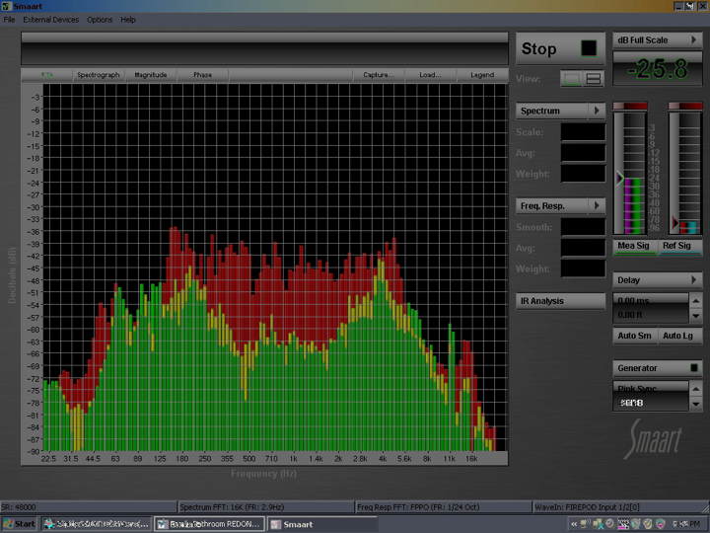

Figure 2: “Weird Room Frequency Response”
(1st Measurement in green, 2nd measurement in yellow)
