Andy Conway, Ryan Ericksen, Dan Green and Ethan Willing
Capturing Room Sound
2/12/13

Abstract
Our project compared the efficiency of several sound sources commonly used to measure room modes in order to find the most practical way to capture the timbre imparted by a room on a sound source. We used a two-microphone (Audix TM1) setup (one 2” from the source directly on axis and one 94” from the source in the corner) because each individual track would already include the speaker’s sound signature, essentially negating the coloration of the speaker when comparing the difference between the tracks. We then compared the close and distant miking of an impulse source (book slammed on floor), pink noise, sine wave sweep and a guitar amplifier in order to see which was the most effective in identifying room modes. By putting each source’s close and distant mikings through a matching equalizer, we were able to generate a response curve showing only the relative difference between the two recordings. Our most effective technique was the sine wave sweep, followed closely by pink noise, because it clearly identified the greatest number of frequency bumps (modes) and contained the greatest dynamic range between the most present room mode crest and its adjacent trough.

Introduction
Our purpose was to find a way to accurately measure “room tone” using only the equipment typically found in a studio. A room’s sound is dependent on many variables, such as absorption, diffusion and reflection, but we mostly focused on what we believed to be the biggest determinant of a room’s frequency content: the room modes. Room modes are created by one, two and three dimensional standing waves in a room and are a function of a room’s geometry.
Through our measurements, we aimed to generate a room EQ that could accurately represent the frequency content added to a sound source by a particular space. Theoretically, this room EQ could capture the sound signature of a great sounding space. This signature could then be applied to a dry recording in an area with a much less pleasing room sound (assuming that the recording in the second rom is “dead” enough to not cause excess coloration by the second room). We predicted that the effectiveness of each room equalizer would be based on two criteria: the room EQ that correctly identified (compared to calculated room modes) the greatest number of modal resonance peaks and the EQ that showed the greatest difference in dynamic range between the room mode peaks and their adjacent troughs.
We would then run these EQs through a subjective test by backwards applying the generated room EQ to our “dry” guitar signal and comparing the resultant artificially created room tone to the natural sound of the room at our distant miking position. Theoretically, if the difference between what our mics picked up is just the sound imparted by the room, then the applied EQ of the sound source that was most effective in identifying the room modes should sound almost identical to our distant miking. Although the data obtained from this type of test will not be empirically strong in proving our thesis, it should let us know whether or not our objective criteria for comparing the room EQs did a good job of producing the desired result (realistic sounding room tone replication), an equally subjective measure in a studio setting.

Method
The equipment we used included: 2 Audix TM1 microphones, 2 microphone stands, 1 Logitech speaker, 1 Fender Hot Rod Deluxe guitar amplifier, 1 Epiphone Les Paul, 1 Hardcover Textbook (impulse source), SHAART acoustic analysis program, Audacity (for signal generator), Pro Tools and Izotope Ozone 5 (for matching equalizer).
We chose to use measurement microphones because of their flat frequency response and omnidirectional polar pattern, which is important in eliminating variables such as altered off-axis frequency response and proximity effect. The Logitech speaker and Fender guitar amp were not able to reproduce a flat frequency response, but our experiment was designed to eliminate this need, although a flatter set of speakers may make the results more accurate.
Dimensions of the Room Being Measured
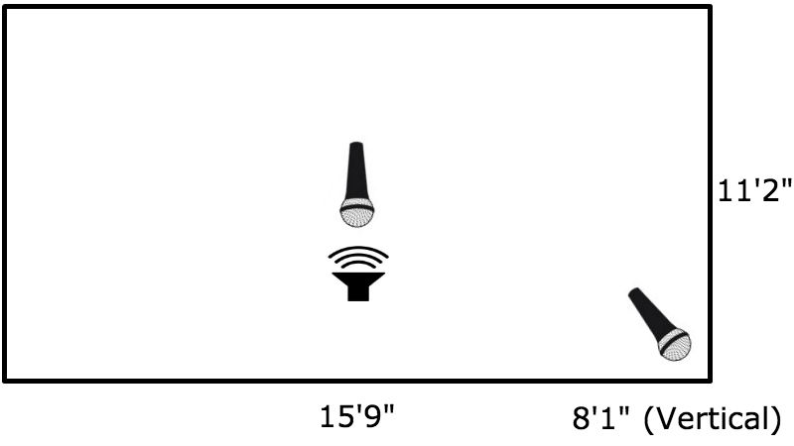
We first set up the sound source to be centered in our room in our x dimension and three quarters of the way towards the wall in our y dimension. The speaker was sitting on the floor, resting on top of a carpet. We chose the sound source to be mostly in the center of the room because, although this placement would excite fewer room modes overall, the close microphone (2” from grille) would also pick up fewer room modes, giving us a less colored reference. Conversely, the second microphone (94” from grille) was placed directly in the corner because the corners of a room are where the three axial (one dimensional) modes meet. The corner is the area of the room most affected by room modes.
The first recording we did was a pink noise speaker reference. We boxed in the speaker on three sides and above by pillows and a mattress (rear of the speaker). This gave us the frequency response of our speaker and microphone together when compared to computer generated pink noise. We removed the pillows for the further trials as to not affect the dispersion of sound in the room.
The next trial we did was full band pink noise. We conducted five trials lasting 3 seconds each. After these trials, we recorded a 15 second logarithmic sine wave sweep from 0 Hz to 20 kHz. After recording 5 sine wave sweep trials we moved on to impulse response. We performed 10 trials by slamming a hardcover textbook onto the wooden floor. Finally, we replaced the Logitech speaker with a Fender guitar amplifier and performed a single trial lasting about 20 seconds.

Results
Once the recordings were processed through iZotope Ozone, we were left with a frequency graph for the difference between the close mic and the room mic for each source, essentially showing us the “sound of the room.”
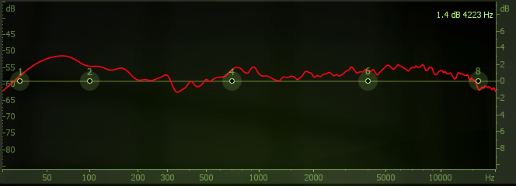
Impulse
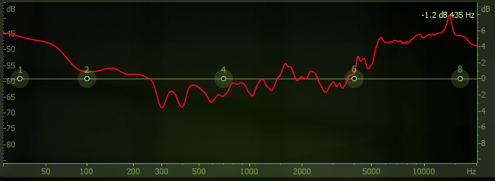
Guitar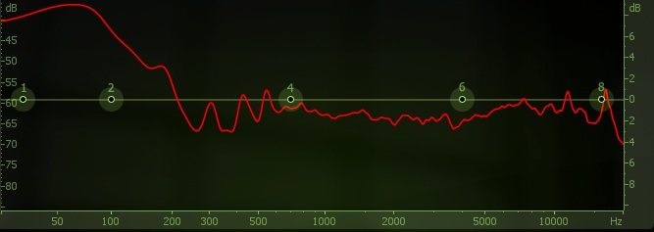
Sine Wave Sweep
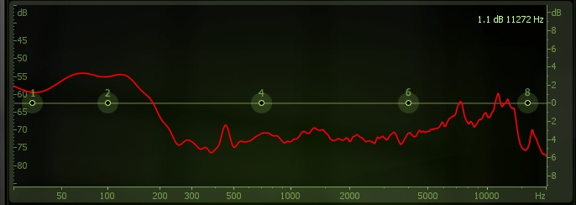
Pink Noise

Each graph showed slightly different results, with the sine wave sweep and pink noise showing the most dynamic examples of room modes. This result most likely occurred because those two sources excited the most frequencies in the room. The issue with the guitar recording was that it did not appear to have an adequate frequency bandwidth to truly capture the room. The impulse graph also had issues and it was decided that the miking technique used probably measured more of the reverb of the room than the frequency response and room modes. The graphs were then compared with our calculated room modes to check that the software and procedure were correctly done to measure the sound of the room.
Frequency (Hz) | Nx | Ny | Nz | Frequency (Hz) | Nx | Ny | Nz
36.2 | 0 | 1 | 0 | 101.1 | 0 | 2 | 1
50.9 | 1 | 0 | 0 | 101.8 | 2 | 0 | 0
62.4 | 1 | 1 | 0 | 108.0 | 2 | 1 | 0
70.5 | 0 | 0 | 1 | 108.6 | 0 | 3 | 0
72.4 | 0 | 2 | 0 | 123.8 | 2 | 0 | 1
79.3 | 0 | 1 | 1 | 141.1 | 0 | 0 | 2
87.0 | 1 | 0 | 1 | 145.7 | 0 | 1 | 2
88.5 | 1 | 2 | 0 | 150.0 | 1 | 0 | 2
94.2 | 1 | 1 | 1 | 152.7 | 3 | 0 | 0
101.1 | 0 | 2 | 1 | 211.6 | 0 | 0 | 3
Calculated Room Modes
The comparison showed that the room modes shown in the recordings of the room were accurate, especially around 70Hz. We believe that this frequency stood out because it was the overlap of two axial modes, which are the modes that have the greatest influence on a room’s sound. Once the results were deemed satisfactory, the EQ curves were placed onto a guitar recording from a separate room to see if the curves, or sound signatures, could produce a similar room sound. The impulse sound gave a poor result upon listening, as expected. The sine wave sweep and the pink noise tests, deemed to be the most visually accurate, ended up producing unpleasant tones when put in place. Surprisingly, the guitar curve, the most inaccurate one in appearance, produced the most similar sounding result to the original room. The most likely reason for this result was that the guitar recording excited a set of frequencies specific to our guitar setup and song key (which would be constant for both recordings) instead of exciting all frequencies like the sine wave sweep and the pink noise. More trials would be needed to see how this generated EQ would affect other sound sources and instruments.

Conclusion
While the sine wave sweep and the pink noise trials produced the most accurate representations of the room modes, they did not serve to be very helpful in a practical situation. These sources were chosen in order to accurately represent a room, which in these tests, they did not. The impulse was not expected to produce great results and it performed about as expected. The guitar sample provided the best results possibly only because it was being used on the same instrument. More testing is needed to determine whether or not the sound a room can be captured and recreated on a larger scale, for instance an entire track of various instruments, but this test shows that it can theoretically be done. An ideal test would be to record a song with basic instruments such as guitar, bass, drums, and vocals in a studio and then record it a bedroom, or any other “worse sounding” room and compare the tracks with and without the room EQ curves being added. This would give an even more real world example and application for this test.

References
Everest, F. Alton and Pohlmann, Ken C. Master Handbook of Acoustics. McGraw Hill Publishing, 2001, New York, NY.

