Gobo Placement and Frequency Response: Baffle Placement and its Effect on Microphones’ Ability to Capture Frequency and Decibel Levels
By James Vrettos, Tom Dicks, Cameron Merenick
Belmont University
Abstract
The main goal of this experiment was to provide an investigation into a gobo’s ability to block, refract, or absorb sound energy when placed at different locations in front of an active sound source by carefully mimicking a realistic studio setup. A typical studio setup will normally include gobos of varying dimensions and microphones placed at varying distances throughout the room. The method of gathering data included measuring the frequency range and SPL response of each microphone placed in various proximities behind gobos of different dimensions. The main focus of the measurements was on gobo placement directly at the sound source and gobo placement in front of a secondary microphone 5 feet away from the source to compare the two in their effectiveness in diminishing frequency response and amplitude (dBFS) across the frequency spectrum. The results of these experiments ultimately showed that gobo placement at the sound source is generally less effective at diminishing sound than when placed directly in front of a secondary microphone five feet from the source.

Introduction
How much energy in dBSPL and what range of frequencies are absorbed or allowed to diffract around a gobo? Do different timbres have different diffraction properties? Do gobos of different dimensions absorb some frequencies better than others, and are they more effective at reducing SPL at closer distances?
Gobos are a very valuable asset to have in a studio when it comes to diminishing unwanted audio frequencies and achieving sonic clarity. Therefore it is important for an Audio Engineer to know how best to use this tool in order to better accomplish his or her tasks. The goal of this experiment is to further the knowledge of Audio Engineers regarding sound isolation and the effectiveness of different gobos placed at different distances when related to varying frequencies.
Methods
The first step in starting this experiment and being able to acquire accurate data began with booking Quonset Hut Studio. This studio was chosen in particular because it is ideal when having a basic tracking session due to the size and volume of the room and because of the wide selection of different gobos from which to choose. Collecting our data while simulating a tracking session environment was ideal due to the fact that this would be the most logical time for an audio engineer to setup gobos in order stop sounds from bleeding through into different microphones. The goal of the experiment was to find out what exactly would be the best placement of a gobo, what frequencies that gobo would block or attenuate, and what factors would contribute to one gobo being more effective than another.
In order to test this, the experiment was started by placing four Shure SM57 uni-directional microphones throughout the room. One microphone was placed directly on the sound source, the second microphone was placed five feet from the source, the third microphone was placed ten feet from the source, and the fourth microphone was positioned at a distance of fifteen feet from the source. Next, a gobo was placed right in front of the microphone that was 5ft from the sound source (see Figure 1), and then later moved to directly behind the source microphone (see Figure 2). This was done to simulate two possible positions that one may place a gobo in a studio setting and to measure the differences that would take place with each respective placement.
The first time that the experiment was attempted, we brought in an amplifier and played an electric guitar through it at 220 Hz with a measured sound pressure level of 90dBSPL. We placed each of the 4 different gobos at five feet away and then moved them to the sound source as discussed above. We then repeated this step using a bass guitar with a 200 Hz tone and a SPL metering of 90dBSPL.
After looking back at the first attempt of the experiment, a few major errors were noticed that would have skewed any attempt to calculate and obtain accurate data. The first one was that the initial recording had required a live person to pluck either the guitar or the bass string. This way of doing the experiment resulted in applying inconstant amounts of force that would cause the string to vibrate at different intensities. In order to fix this problem, we decided to pre-record the guitar and bass playing the note at 90dBSPL and then run that note through our sound source to get a more congruent signal with the same intensity every time the note was played. The next error that was accounted for was the need to record more than just one take with each gobo placement so that there would be a way to compare the data and make sure it was consistent. To do this, three takes of each of the gobos at the sound source and at 5 feet were recorded to provide the data needed to create an average. The last error we noticed was that, during the first attempt, we had neglected to use an instrument with a prominent transient response. In order to remedy this, the sound of a djembe was used to see if a percussion instrument would achieve different results then the other more melodic instruments. After gathering all the recordings and organizing them each into separate playlists, the plug-in Blue Cat Audio Frequency Analyzer was used to analyze the content of each sound clip. The frequency range and decibel levels were examined from each recording at the 0, 5, 10, and 15 foot distances, and at the different gobo placements as discussed above.
Results
Drum
Peak Frequency Analysis
With no gobo, the change in dBFS was 5dB at 5 feet, 8.5 dB at 10 feet, and a drop of 10dB at 15 feet. With gobos placed 5 feet from the sound source, the average drop in dB at 5 feet was 18.25 dB, 17.75 dB at 10 feet, and 18.75 dB at 15 feet (see figure 3). With gobos placed directly on the sound source, the average dB change was 20dB at 5 feet, 16dB at 10 feet, and 24dB at 15 feet (see figure 4).
Bass Roll Off Analysis
With no gobo, the bass roll-off at the source microphone was 23Hz. At the 5 foot microphone, the bass roll-off was 47Hz, at the 10 foot microphone 35Hz, and 45Hz at the 15 foot microphone (see figure 5). With gobos placed 5 feet from the sound source, the 5 foot microphone experienced a bass roll off of 37.25Hz, at 10 feet 29.25Hz, and at 15 feet 27Hz (see figure 5). With the gobo on directly on the sound source, the bass roll-off at the 5 foot microphone was 37.25Hz. At 10 feet, the roll-off was 29.25Hz, and at 15 feet it was 29.25 Hz (see figure 6).
High Frequency Analysis
With no gobo, the highest frequency encountered at the source microphone was 11kHz. At the 5 foot microphone, the highest frequency was 13kHz. At 10 feet the highest frequency was 13kHz, and at 15 feet the highest frequency was 10kHz (see figure 7). With the gobos 5 feet from the sound source, the average highest frequency encountered was 5.55kHz at the 5 foot microphone. At 10 feet, the highest frequency was 9.7kHz, and at 15 feet was 8.9kHz (see figure 7). With the gobos directly at the sound source, the average highest frequency encountered at the 5 foot microphone was 8.5kHz. At 10 feet the highest frequency was 9.2kHz, and at 15 feet the highest frequency was 7.3kHz (see figure 8).
Guitar
Peak Frequency Analysis
With no gobo, the change in dBFS was 9dB at 5 feet, 9dB at 10 feet, and a drop of 14dB at 15 feet (see figure 9). With gobos placed 5 feet from the sound source, the average drop in dB at 5 feet was 20.75 dB, 14.5 dB at 10 feet, and 18.5 dB at 15 feet (see figure 9). With gobos placed directly on the sound source, the average dB change was 19dB at 5 feet, 17.5dB at 10 feet, and 22dB at 15 feet (see figure 10).
Bass Roll Off Analysis
With no gobo, the bass roll-off at the source microphone was 24Hz. At the 5 foot microphone, the bass roll-off was 47Hz, at the 10 foot microphone 47Hz, and 26Hz at the 15 foot microphone (see figure 11). With gobos placed 5 feet from the sound source, the 5 foot microphone experienced a bass roll off of 44.3Hz, at 10 feet 54.25Hz, and at 15 feet 49.25Hz (see figure 11). With the gobo on directly on the sound source, the bass roll-off at the 5 foot microphone was 42.8Hz. At 10 feet, the roll-off was 40.8Hz, and at 15 feet it was 37.75 Hz (see figure 12).
High Frequency Analysis
With no gobo, the highest frequency encountered at the source microphone was 8kHz. At the 5 foot microphone, the highest frequency was 6kHz. At 10 feet the highest frequency was 6.5kHz, and at 15 feet the highest frequency was 6kHz (see figure 13). With the gobos 5 feet from the sound source, the average highest frequency encountered was 5.7kHz at the 5 foot microphone. At 10 feet, the highest frequency was 6.1kHz, and at 15 feet was 4.9kHz (see figure 13). With the gobos directly at the sound source, the average highest frequency encountered at the 5 foot microphone was 5.7kHz. At 10 feet the highest frequency was 5.8kHz, and at 15 feet the highest frequency was 5.1kHz (see figure 14).
Bass
Peak Frequency Analysis
With no gobo, the change in dBFS was 10dB at 5 feet, 11dB at 10 feet, and a drop of 15dB at 15 feet (see figure 15). With gobos placed 5 feet from the sound source, the average drop in dB at 5 feet was 22.5 dB, 13.3 dB at 10 feet, and 19.8 dB at 15 feet (see figure 15). With gobos placed directly on the sound source, the average dB change was 19dB at 5 feet, 17.8dB at 10 feet, and 19.8dB at 15 feet (see figure 16).
Bass Roll Off Analysis
With no gobo, the bass roll-off at the source microphone was 10Hz. At the 5 foot microphone, the bass roll-off was 22Hz, at the 10 foot microphone 22Hz, and 24Hz at the 15 foot microphone (see figure 17). With gobos placed 5 feet from the sound source, the 5 foot microphone experienced a bass roll off of 24Hz, at 10 feet 22.5Hz, and at 15 feet 33.3Hz (see figure 17). With the gobo on directly on the sound source, the bass roll-off at the 5 foot microphone was 24Hz. At 10 feet, the roll-off was 23.3Hz, and at 15 feet it was 25 Hz (see figure 18).
High Frequency Analysis
With no gobo, the highest frequency encountered at the source microphone was 11kHz. At the 5 foot microphone, the highest frequency was 7kHz. At 10 feet the highest frequency was 4kHz, and at 15 feet the highest frequency was 4kHz (see figure 19). With the gobos 5 feet from the sound source, the average highest frequency encountered was 3.3kHz at the 5 foot microphone. At 10 feet, the highest frequency was 4.7kHz, and at 15 feet was 4.1kHz (see figure 19). With the gobos directly at the sound source, the average highest frequency encountered at the 5 foot microphone was 5kHz. At 10 feet the highest frequency was 5.8kHz, and at 15 feet the highest frequency was 4.2kHz (see figure 20).
Factors that may have led to some data outliers
We used Shure SM57 microphones to capture our data and make our subsequent measurements. SM57 microphones have a frequency response of 40Hz-15kHz, which is not the complete range of human hearing, so we may have missed a few overtones in the extrema (“SM57”). Directional microphones also exhibit a phenomenon called the Proximity Effect, which is an increase in dB in the lower frequency register when a microphone is placed close to a sound source. For the SM57, Shure rates the frequency boost as a 6-10dB boost in frequencies below 100Hz when the microphone is ~¼ “ from the sound source (“SM57”). In order to do this experiment more accurately, we would have opted to use omni-directional microphones, which capture sound at all angles and do not experience the proximity effect. Although this may be more effective for measurements, the use of an omni-directional microphone in this sort of setting is impractical. In a typical session, a musician will use either a microphone with a bi-directional or a cardioid polar pattern, but it will in most cases be the latter.
Final Conclusions
When trying to block frequencies encountered by a drum/transient response signal, using a thicker and wider gobo (such as gobo 4), will be most effective, and employing a taller, thinner gobo (such as gobo 3 at source) will be the least effective (see figures 21 and 22). Guitars are better blocked with a taller gobo (such as gobo 3) and are most transparent with a medium height, thinner gobo (gobo 2) (see figures 23 and 24). When trying to effectively block bass frequencies, a thicker and wider gobo at the source (such at gobo 4 source) will be the best option, and a taller and thinner gobo (such as gobo 3) will allow the most bleed of the signal (see figures 25 and 26).

References
"SM57." Shure. Shure Inc. Web. Retrieved December 1, 2013, from http://www.shure.com/americas/products/microphones/sm/sm57-instrument-microphone

Appendix

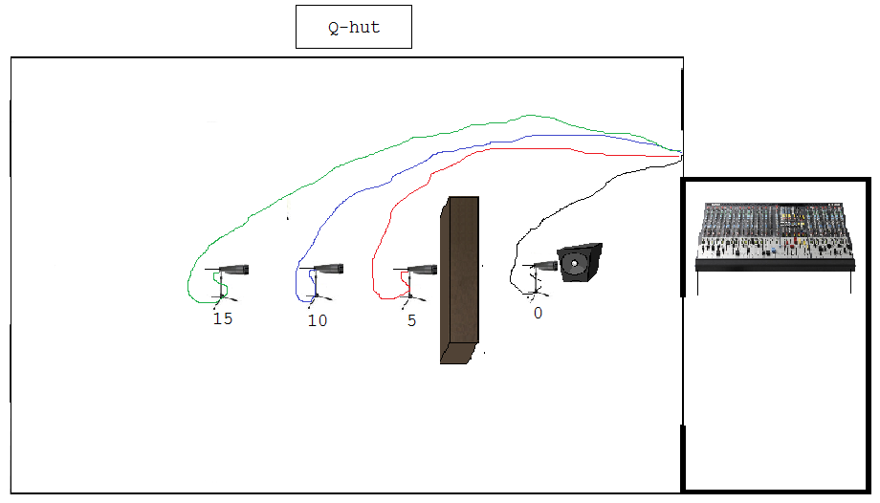
Figure 1, Gobo placed 5ft from sound source

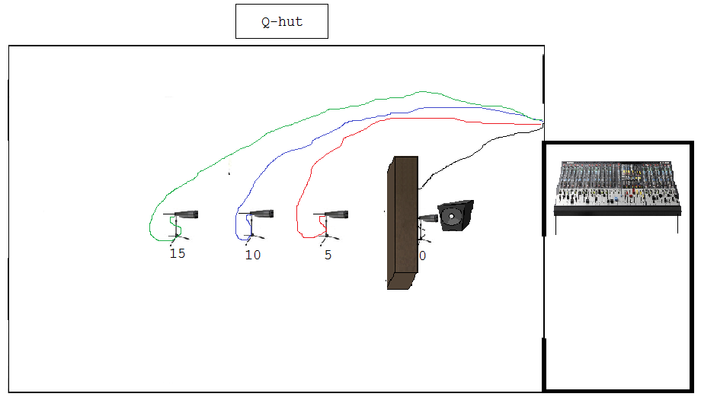
Figure 2, Gobo placed directly in front of sound source

Figure 3

Figure 4

Figure 5

Figure 6

Figure 7

Figure 8

Figure 9

Figure 10

Figure 11

Figure 12

Figure 13

Figure 14

Figure 15

Figure 16

Figure 17

Figure 18

Figure 19

Figure 20

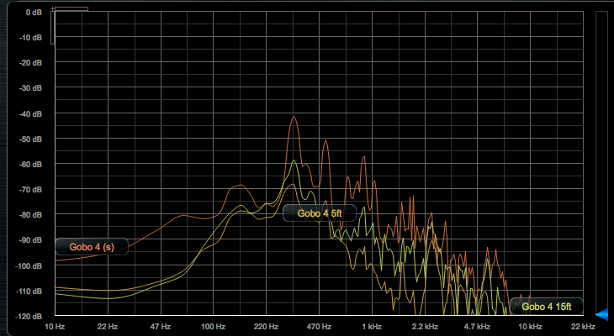
Figure 21, Gobo 4 Drum

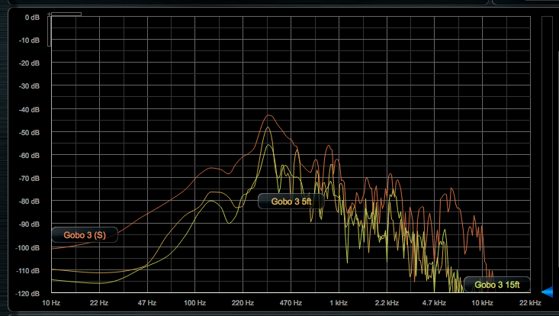
Figure 22, Gobo 3 Source Drum
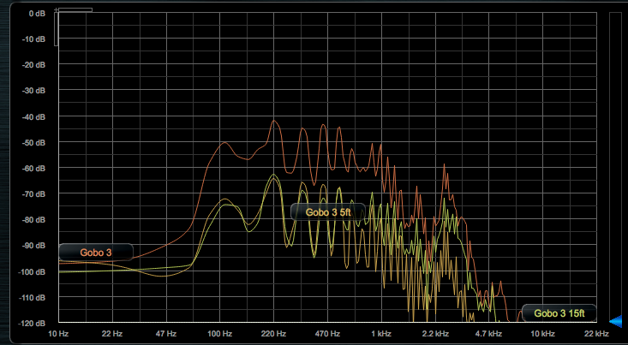
Figure 23, Gobo 3 Guitar
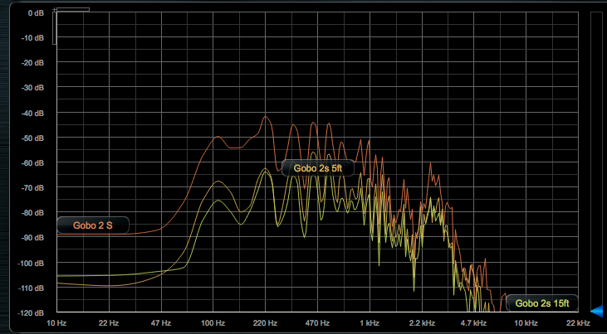
Figure 24, Gobo 2 Guitar

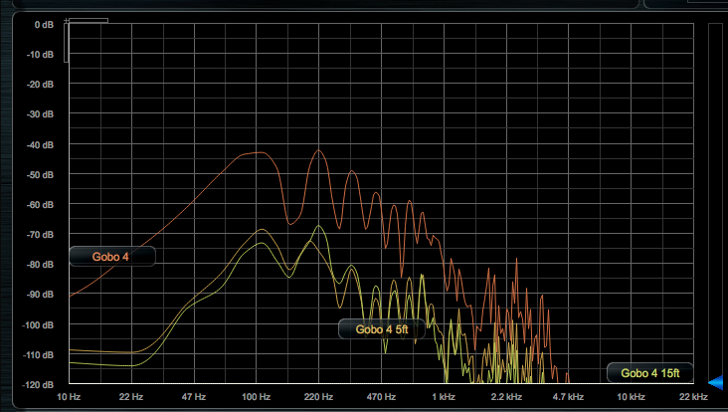
Figure 25, Gobo 4 Source, Bass Guitar

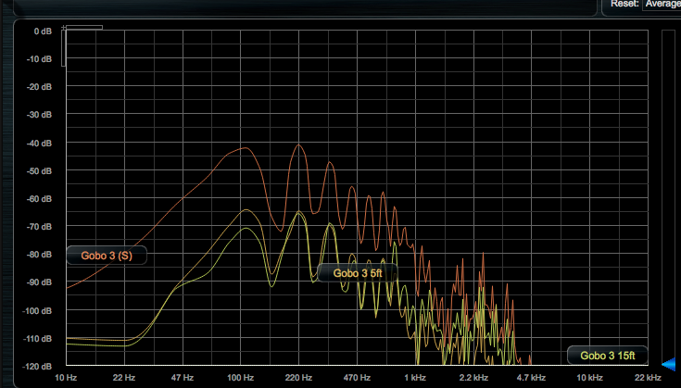
Figure 26, Gobo 3, Bass Guitar

Drum
No Gobo
Mic Placement (ft) | Peak (dB) | Peak Freq (Hz) | Bass roll off (dB) | Bass R.O (Hz) | Highest Freq (kHz) | HF (dB)
0 | -41 | 345 | -99 | 22 | 11 | -117
5 | -44.9 | 345 | -110 | 47 | 13 | -118
10 | -47 | 345 | -110 | 34.5 | 13 | -118
15 | -50 | 345 | -112 | 45 | 10. | -116

Gobo 1
Mic Placement | Peak (dB) | Peak Freq (Hz) | Bass roll off (dB) | Bass R.O (Hz) | Highest Freq (khz) | HF (dB)
0 | -40 | 345 | -98 | 22 | 10.4 | -114
5 | -57 | 345 | -110 | 39 | 6.2 | -115
10 | -63 | 345 | -114 | 27 | 10 | -118
15 | -60 | 345 | -114 | 27 | 7.95 | -116

Gobo 1 at Source
Mic Placement (ft) | Peak (dB) | Peak Freq (Hz) | Bass roll off (dB) | Bass R.O (Hz) | Highest Freq (kHz) | HF (dB)
0 | -47 | 345 | -94 | 25 | 12.5 | -118
5 | -63 | 345 | -110 | 45 | 7 | -117
10 | -54 | 345 | -113 | 25 | 9.5 | -113
15 | -62 | 345 | -114 | 25 | 8 | -117

Gobo 2
Mic Placement (ft) | Peak (dB) | Peak Freq (Hz) | Bass roll off (dB) | Bass R.O (Hz) | Highest Freq (kHz) | HF (dB)
0 | -40 | 345 | -105 | 23 | 12 | -115
5 | -60 | 345 | -112 | 47 | 6 | -116
10 | -50 | 345 | -113 | 25 | 9.5 | -118
15 | -62 | 345 | -114 | 25 | 9.57 | -117

Gobo 2 at source
Mic Placement (ft) | Peak (dB) | Peak Freq (Hz) | Bass roll off (dB) | Bass R.O (Hz) | Highest Freq (kHz) | HF (dB)
0 | -40 dB | 345 Hz | -105 dB, | 24Hz | 10.5 kHz | -118
5 | -60 dB | 345 Hz | -112 dB, | 24 Hz | 10.5 kHz | -117
10 | -51 dB | 345 Hz | -112 dB, | 24 Hz | 10.5 KHz | -115
15 | -62 dB | 345Hz | -114 dB, | 24 Hz | 10 kHz | -117

Gobo 3
Mic Placement (ft) | Peak (dB) | Peak Freq (Hz) | Bass roll off (dB) | Bass R.O (Hz) | Highest Freq (kHz) | HF (dB)
0 | -41 | 345 | -95 | 22 | 12.5 | -114
5 | -47 | 345 | -112 | 27 | 6.2 | -116
10 | -54 | 345 | -113 | 24 | 11 | -117
15 | -54 | 350 | -112 | 24 | 8 | -116

Gobo 3 at source
Mic Placement (ft) | Peak (dB) | Peak Freq (Hz) | Bass roll off (dB) | Bass R.O (Hz) | Highest Freq (kHz) | HF (dB)
0 | -43 | 345 | -104 | 24 | 11 | -117
5 | -47 | 345 | -111 | 30 | 10.5 | -113
10 | -52 | 345 | -113 | 24 | 11 | -115
15 | -65 | 300 | -110 | 37 | 6.7 | -116

Gobo 4
Mic Placement (ft) | Peak (dB) | Peak Freq (Hz) | Bass roll off (dB) | Bass R.O (Hz) | Highest Freq (kHz) | HF (dB)
0 | -39 | 345 | -105 | 23 | 10 | -115
5 | -68 | 345 | -110 | 40 | 3.7 | -116
10 | -64 | 350 | -112 | 25 | 8 | -116
15 * | -57 | 360 | -112 | 25 | 9.8 | -114
*Gap between 7.5 kHz and 8.5 kHz

Gobo 4 at source
Mic Placement (ft) | Peak (dB) | Peak Freq (Hz) | Bass roll off (dB) | Bass R.O (Hz) | Highest Freq (kHz) | HF (dB)
0 | -47 | 345 | -95 | 22 | 12 | -118
5 | -71 | 345 | -111 | 40 | 9 | -115
10 | -67 | 330 | -111 | 40 | 9.5 | -118
15 | -66 | 345 | -114 | 30 | 7.2 | -116

Guitar
No Gobo
Mic Placement (ft) | Peak (dB) | Peak Freq (Hz) | Bass roll off (dB) | Bass R.O (Hz) | Highest Freq (kHz) | HF (dB)
0 | -41 | 220 | -101 | 24 | 8 | -112
5 | -50 | 220 | -109 | 47 | 6 | -115
10 | -50 | 220 | -110 | 47 | 6.5 | -116
15 | -55 | 220 | -114 | 25 | 6 | -116
Gobo 1
Mic Placement (ft) | Peak (dB) | Peak Freq (Hz) | Bass roll off (dB) | Bass R.O (Hz) | Highest Freq (kHz) | HF (dB)
0 | -43 | 220 | -80 | 30 | 8 | -115
5 | -63 | 220 | -100 | 70 | 4.7 | -116
10 | -54 | 220 | -100 | 70 | 6.5 | -117
15 | -56 | 220 | -104 | 70 | 5.5 | -118

Gobo 1 at Source
Mic Placement (ft) | Peak (dB) | Peak Freq (Hz) | Bass roll off (dB) | Bass R.O (Hz) | Highest Freq (kHz) | HF (dB)
0 | -42 | 220 | -99 | 25 | 8 | -114
5 | -68 | 220 | -109 | 30 | 4.7 | -115
10 | -60 | 220 | -110 | 47 | 5. | -117
15 | -63 | 220 | -111 | 32 | 4.2 | -116

Gobo 2
Mic Placement (ft) | Peak (dB) | Peak Freq (Hz) | Bass roll off (dB) | Bass R.O (Hz) | Highest Freq (kHz) | HF (dB)
0 | -43 | 220 | -90 | 45 | 7 | -116
5 | -67 | 220 | -109 | 30 | 4.5 | -112
10 | -50 | 660 | -110 | 47 | 6 | -118
15 | -62 d | 220 | -112 | 30 | 6.5 | -115

Gobo 2 at Source
Mic Placement (ft) | Peak (dB) | Peak Freq (Hz) | Bass roll off (dB) | Bass R.O (Hz) | Highest Freq (kHz) | HF (dB)
0 | -43 | 220 | -90 | 45 | 11 | -116
5 | -56 | 440 | -108 | 47 | 6 | -112
10 | -56 | 660/440 | -118 | 47 | 6 | -112
15 | -63 | 660 | -111 | 47 | 6 | -115

Gobo 3
Mic Placement (ft) | Peak (dB) | Peak Freq (Hz) | Bass roll off (dB) | Bass R.O (Hz) | Highest Freq (kHz) | HF (dB)
0 | -41 | 220 | -100 | 25 | 8 | -113
5 | -65 | 220 | -98 | 47 | 4.5 | -108
10 | -56 | 660 | -96 | 55 | 6 | -112
15 | -63 | 220 | -100 | 50 | 5.8 | -117

Gobo 3 at Source
Mic Placement (ft) | Peak (dB) | Peak Freq (Hz) | Bass roll off (dB) | Bass R.O (Hz) | Highest Freq (kHz) | HF (dB)
0 | -42 | 220 | -95 | 27 | 8.2 | -116
5 | -56 | 440 | -108 | 47 | 6.1 | -113
10 | -56 | 440/660 | -110 | 22 | 6 | -116
15 | -63 | 660 | -111 | 25 | 5.8 | -112

Gobo 4
Mic Placement (ft) | Peak (dB) | Peak Freq (Hz) | Bass roll off (dB) | Bass R.O (Hz) | Highest Freq (kHz) | HF (dB)
0 | -43 | 220 | -104 | 29 | 8.5 | -115
5 | -58 | 220 | -109 | 30 | 4 | -113
10 | -50 | 220 | -110 | 47 | 6 | -114
15 | -63 | 220 | -110 | 47 | 5.7 | -115

Gobo 4 at Source
Mic Placement (ft) | Peak (dB) | Peak Freq (Hz) | Bass roll off (dB) | Bass R.O (Hz) | Highest Freq (kHz) | HF (dB)
0 | -42 | 220 | -97 | 44 | 11 | -113
5 | -65 | 220 | -110 | 47 | 6 | -115
10 | -58 | 220 | -114 | 47 | 6 | -116
15 | -68 | 220 | -114 | 47 | 4.3 | -117

Bass
No Gobo
Mic Placement (ft) | Peak (dB) | Peak Freq (Hz) | Bass roll off (dB) | Bass R.O (Hz) | Highest Freq (kHz) | HF (dB)
0 | -42 | 220 | -84 | <10 | 11 | -116
5 | -50 | 220 | -105 | 22 | 7 | -116
10 | -51 | 220 | -110 | 22 | 4 | -112
15 | -56 | 220 | -112 | 24 | 4 | -109

Gobo 1
Mic Placement (ft) | Peak (dB) | Peak Freq (Hz) | Bass roll off (dB) | Bass R.O (Hz) | Highest Freq (kHz) | HF (dB)
0 | -43 | 220 | -94 | <10 | 6 | -112
5 | -65 | 220 | -108 | 24 | 3.6 | -116
10 | -57 | 220 | -110 | 24 | 3.8 | -116
15 | -60 | 220 | -112 | 24 | 3.1 | -117

Gobo 1 at Source
Mic Placement (ft) | Peak (dB) | Peak Freq (Hz) | Bass roll off (dB) | Bass R.O (Hz) | Highest Freq (kHz) | HF (dB)
0 | -42 | 110/220 | -96 dB, | <10 | 9 | -116
5 | -59 | 220 | -108 dB, | 24 | 3.7 | -117
10 | -56 | 220 | -109 dB | 22 | 3.7 | -115
15 | -65 | 220 | -109 dB, | 23 | 3.7 | -115

Gobo 2
Mic Placement (ft) | Peak (dB) | Peak Freq (Hz) | Bass roll off (dB) | Bass R.O (Hz) | Highest Freq (kHz) | HF (dB)
0 | -42 | 220 | -81 | <10 | 5.3 | -116
5 | -66 | 110 | -101 | 24 | 2.7 | -118
10 | -56 | 220 | -101 | 22 | 5.3 | -112
15 | -63 | 220 | -97 | 65 | 5.3 | -117

Gobo 2 at Source
Mic Placement (ft) | Peak (dB) | Peak Freq (Hz) | Bass roll off (dB) | Bass R.O (Hz) | Highest Freq (kHz) | HF (dB)
0 | -43 | 220 | -84 | <10 | 9.8 k | -117
5 | -61 | 220 * | -106 | 25 | 5.8 | -117
10 | -58 | 220 | -109 | 25 | 5.7 ∆ | -116
15 | -62 | 220 | -109 | 24 | 5.3 | -117
*overtones at 110 and 440 are almost as loud as 220
∆ large gap between 4kHz and 5kHz for all but at source mic

Gobo 3
Mic Placement (ft) | Peak (dB) | Peak Freq (Hz) | Bass roll off (dB) | Bass R.O (Hz) | Highest Freq (kHz) | HF (dB)
0 | -42 | 220 | -94 | <10 | 11 | -118
5 | -63 | 110 * | -110 | 24 | 3.7 | -118
10 | -56 | 220 | -109 | 20 | 5.8 | -116
15 | -66 | 440 * | -109 | 22 | 4 | -111
*220 is 2dB quieter
∆large gap between 2.7-3.7 kHz

Gobo 3 at Source
Mic Placement (ft) | Peak (dB) | Peak Freq (Hz) | Bass roll off (dB) | Bass R.O (Hz) | Highest Freq (kHz) | HF (dB)
0 | -42 | 220 | -94 dB, | <10 | 10 | -118
5 | -67 | 110/440 * | -108dB, | 25 | 6.8 | -118
10 | -55 | 220 | -109 dB, | 24 | 4 | -108
15 | -67 | 440 ∆ | -112 dB, | 24 | 3.9 | -112
*220 is 2dB quieter than 110/440
∆ Negligable difference with 220 Hz

Gobo 4
Mic Placement (ft) | Peak (dB) | Peak Freq (Hz) | Bass roll off (dB) | Bass R.O (Hz) | Highest Freq (kHz) | HF (dB)
0 | -43 | 220 | -92 | <10 | 6.5 | -118
5 | -66 | 110∆ | -108 | 22 | 3 † | -108
10 | -55 | 220 | -108 | 25 | 4 | -112
15 | -60 | 220 • | -110 | 22 | 4 | -117
∆ negligible difference with 220 Hz
† Very little high end information, only small spikes from 1kHz upwards
•Overtones at 110Hz and 440 Hz are more prominent

Gobo 4 @ Source
Mic Placement (ft) | Peak (dB) | Peak Freq (Hz) | Bass roll off (dB) | Bass R.O (Hz) | Highest Freq (kHz) | HF (dB)
0 | -41 | 220 | -87 | <10 | 6.7 | -108
5 | -69 | 110 | -112 | 27 | 4 | -115
10 | -63 | 220 | -111 | 24 | 4.1 | -114
15 | -67 | 220 | -112 | 24 | 3.8 | -114

